- Sending new dhamaka logo, please use this.

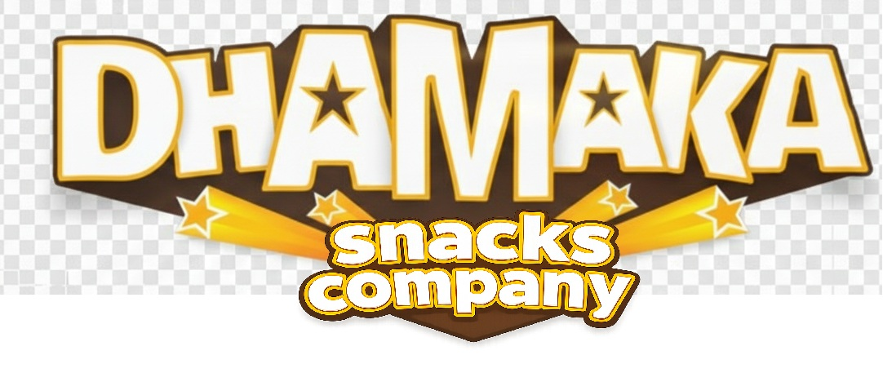
- Remove the side caricature added, they are not looking great.
- The slider looks good The slider can remain
- Below the SLider can you follow the version I sent.
- Remove this – Also, no bestseller, hot and new, favorite etc needed. Just two boxes, on left the DHAMAK PACKET, I am sharing its creative, and on right Shubha prasadam makhana.
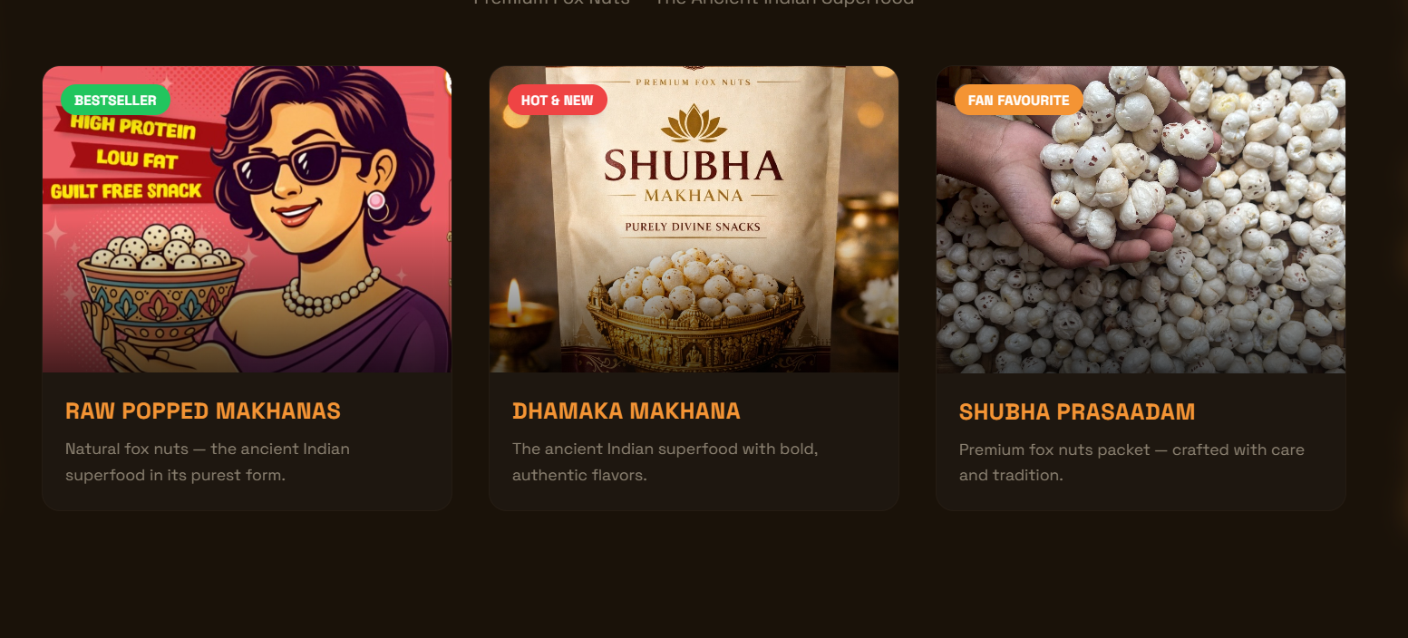

- Remove this
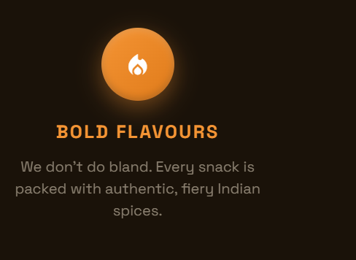

- Remove this


- Launching Soon, and coming soon both are not needed. Also Remove the line – Something incredible is popping up. Stay tuned. Also Shubha has to be in the SAMARKAN FONT. Below is the sample of the samarkan font


SAMARKAN FONT –
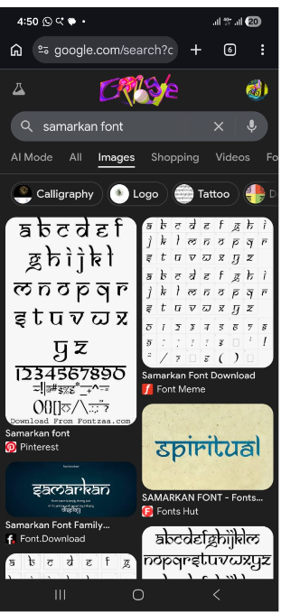

- Correct mail id - dhamakasnackscompany@gmail.com
- City – Sonipat, India.

- All this font in WHITE and slightly better uniform font. Something that is clear, yet not large enough. 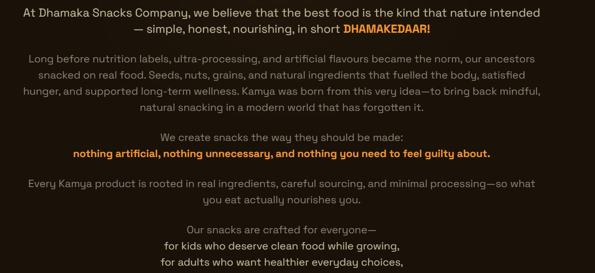



- 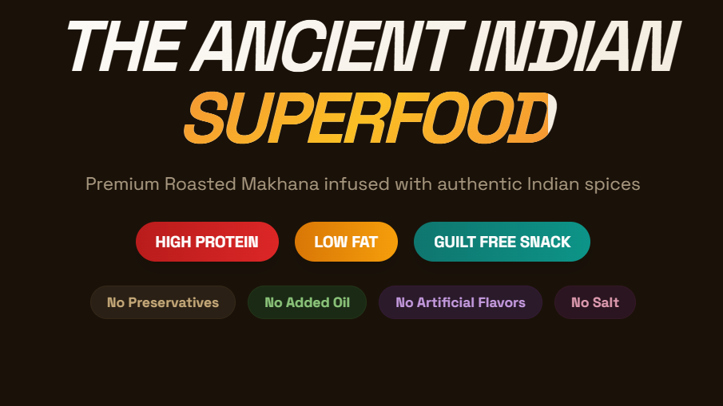
The andcient Indian superfood in white and no italicization needed.
Also, ours are plain makhana, so please don’t mention spices any where . So remove this too - Premium Roasted Makhana infused with authentic Indian spices

- There are two cartoon strips that need to be added, I will be sharing all these in whatsapp documents now. Thanks.

